ALL SCHOOL AMERICAN FLAG
USING STEM AS A FORCE FOR GOOD!

Team Members:
THE ENGINEERING DESIGN PROCESS

IDENTIFY-What is the problem or task?

INVESTIGATE – What do you have to research?

IMAGINE-What solutions do you visualize as you begin thinking about a design?

PLAN-What is your original design?

CREATE-A photo of the design you made!

Note: drag your photo to this document, then double click on the photo to get the handles. Look at the tool bar for ARRANGE, POSITION OR WRAP TEXT. Choose “Behind Text”. Then size and place the photo where you want it! Delete this note when you have your picture in place.
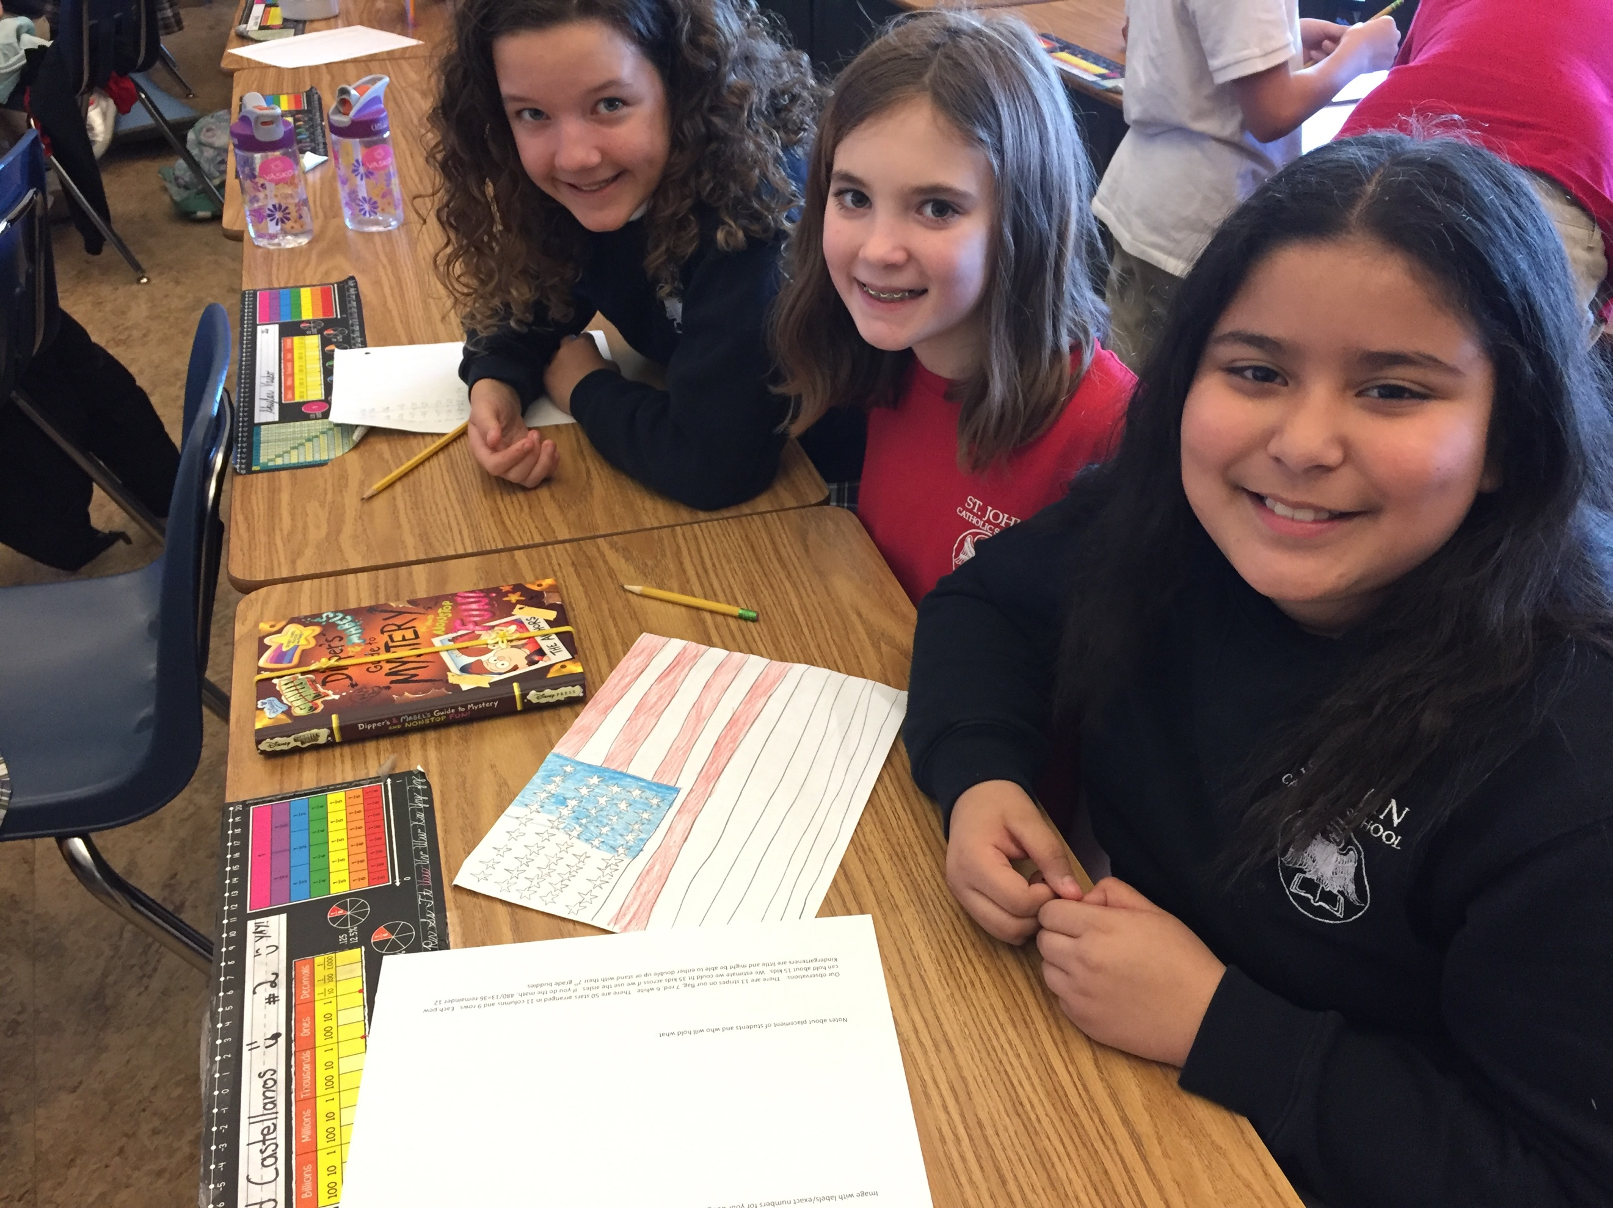

TEST –How can you tell if your design will work?

IMPROVE- Write one or two ways you can improve your design:

COMMUNICATE- Share your design with our school administrators for consideration!
MATH CALCULATIONS:

